⚡ ELECTRICAL CIRCUITS LAB REPORT ⚡

Hybrid 1-Way & 2-Way Lighting Control Circuit

📋 PROJECT INFORMATION

Experiment | Hybrid Lighting Control Circuit

Circuit Type | Series & Parallel (Hybrid)
Switch Types | 1-Way Switch | 2-Way Switch

Components | 2 Lamps, 1 One-Way Switch, 2 Two-Way Switches, AC Power Source

🎯 EXPERIMENT OBJECTIVE

To design and implement a hybrid lighting control circuit that demonstrates both 1-way and 2-way switch configurations using a combination of series and parallel wiring techniques, replicating real-world residential lighting principles.

🔌 CIRCUIT DESCRIPTION

⚡ 1-WAY SWITCH CONFIGURATION

The first section features a 1-way switch connected in series with a single lamp. Current flows from the AC power source, through the switch, and then to the lamp. This configuration allows the lamp to be controlled from a single location — typical of standard bedrooms or bathrooms.

🔄 2-WAY SWITCH CONFIGURATION

The second section employs a 2-way switching system using a traveler/parallel configuration to control the second lamp. This enables the lamp to be turned ON or OFF from either switch regardless of the other's position — ideal for hallways and staircases where multiple control points are required.

🗺️ CIRCUIT LAYOUT & WIRING COLOUR CODE

🔴 RED WIRES | Traveler connections between the two 2-way switches

⬛ BLACK WIRES | Live (main) and return (neutral) paths

📊 SIMULATION RESULTS

CIRCUIT BEHAVIOUR UNDER DIFFERENT SWITCHING STATES

Switch 1 (1-Way) | Switch 2 (2-Way) | Switch 3 (2-Way) | Result
ON | UP | UP | Both ON ✅
OFF | UP | UP | Lamp 1 OFF ❌
ON | UP | DOWN | Lamp 2 ON ✅
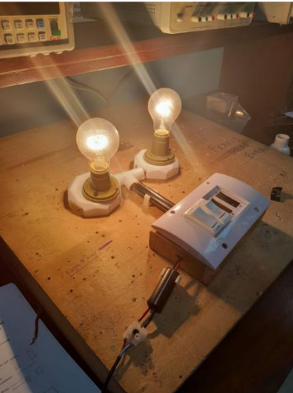
Experimental Result
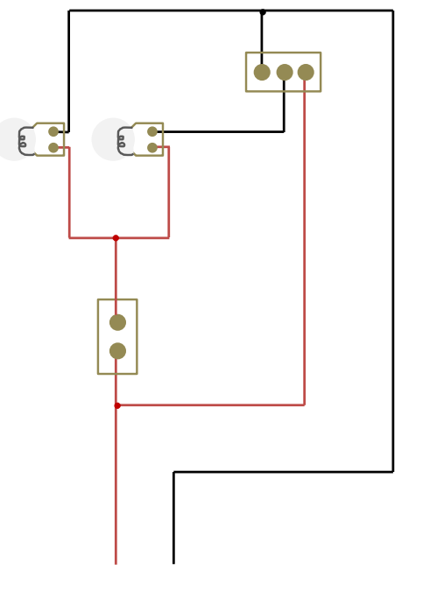
Stimulation Result

🔍 OBSERVATIONS & INSIGHTS

▶ | Lights occasionally exhibited reduced brightness depending on switching states — attributed to internal resistance and unequal current distribution.
▶ | Voltage drops were observed in shared segments of the hybrid circuit, highlighting the impact of circuit design on performance.
▶ | The 2-way switch traveler system successfully allowed the lamp to be toggled from either switch location independently.
▶ | Precise wiring was confirmed to be critical — minor wiring errors caused inconsistent lamp behaviour during initial testing.
▶ | The 1-way switch section performed reliably, with the lamp responding immediately and consistently to switch toggling.

✅ CHOSEN SOLUTION — HYBRID CIRCUIT

WHY THE HYBRID CIRCUIT WAS SELECTED

▶ | Allows independent control of each lamp using different switch configurations.
▶ | Ensures continued functionality even if one lamp or switch section becomes non-operational.
▶ | Provides a clear educational illustration of both series (1-way) and parallel (2-way) connections.
▶ | Incorporates commonly used switch types found in real residential wiring applications.
▶ | Meets all technical and safety criteria while serving as a valuable teaching tool.

📝 CONCLUSION

This experiment successfully demonstrated the fundamental principles of residential lighting control. The hybrid circuit combining a 1-way switch in series with a single lamp, and a 2-way switch traveler system for the second lamp, effectively illustrated how both simple and complex control systems coexist in unified circuits.

Key principles covered: switch logic, circuit configuration, voltage drop behaviour, load sharing, and practical effects of electrical design — all confirmed through hands-on testing and observation.

⚡ Experiment Completed Successfully ⚡

